Visualizing Housing Market Trends: An Analysis of Sale Prices and Features using Tableau

Activity 1.1: Count of Transformed_Housing_Data

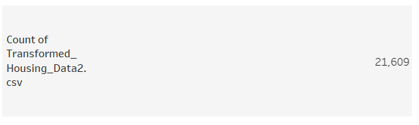

 Activity 1.2:  Average Sale Prices

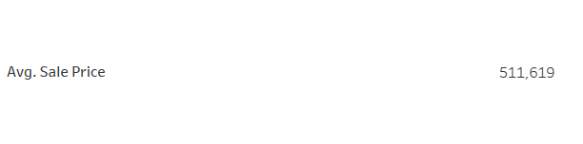

Activity 1.3: Area of House from Basement(in Sqft)

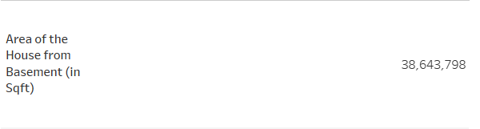

Activity 1.4 Total Sales by Years Since Renovation

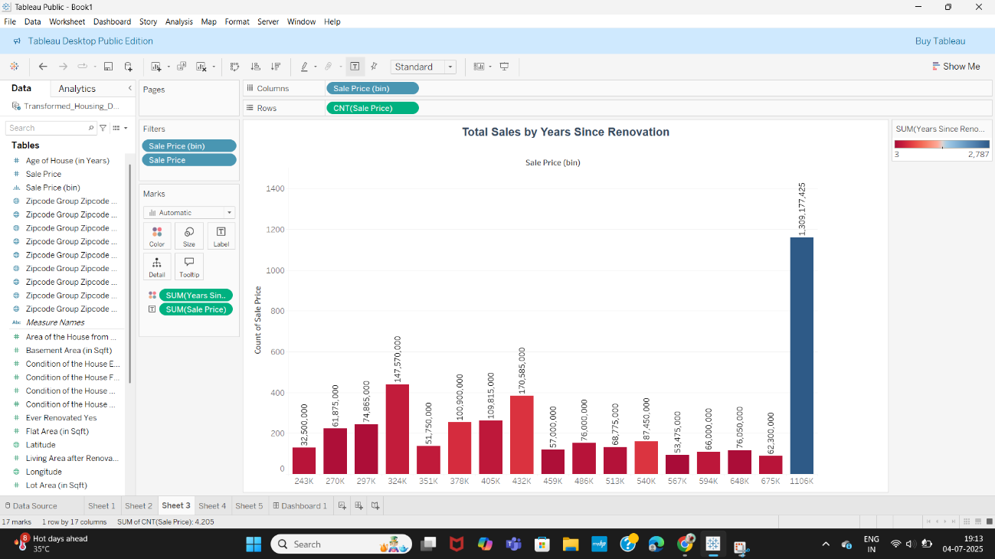

Activity 1.5 Distribution of House Age by Renovation Status

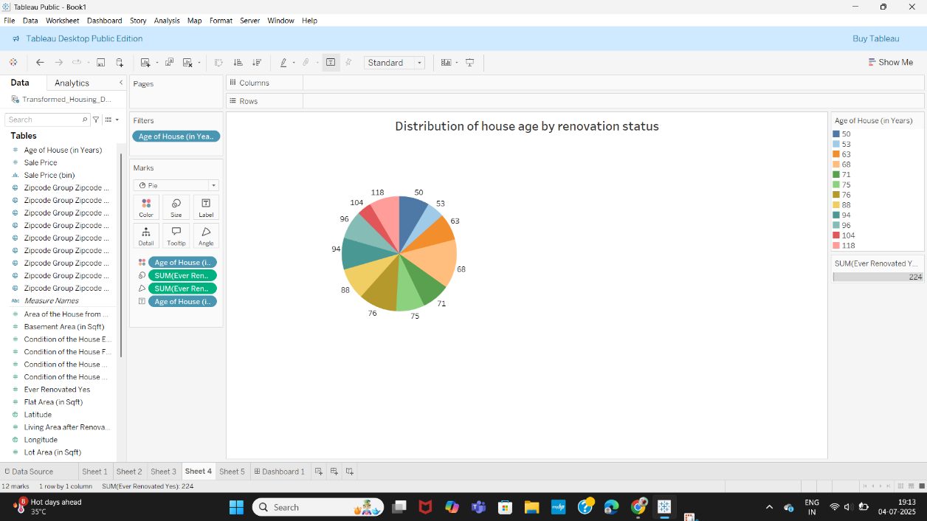

Activity 1.6 House Age Distribution by Number of Bathrooms, Bedrooms, and Floors

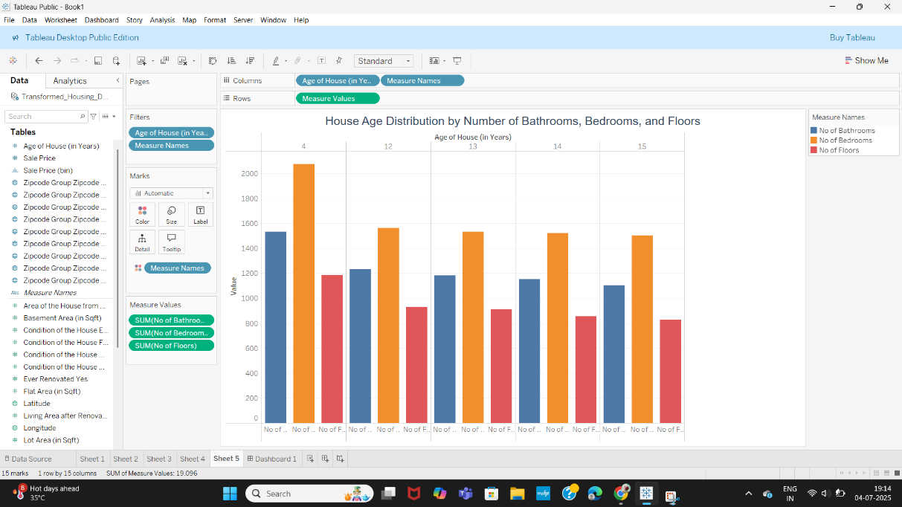

Responsive and Design of Dashboard

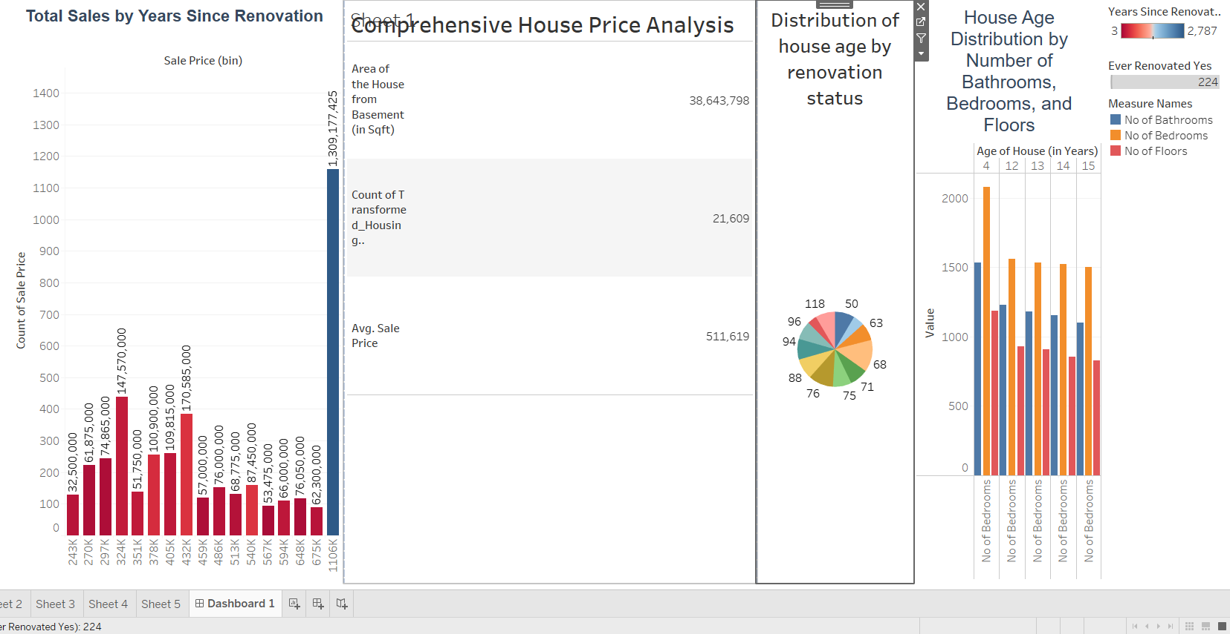

Story View

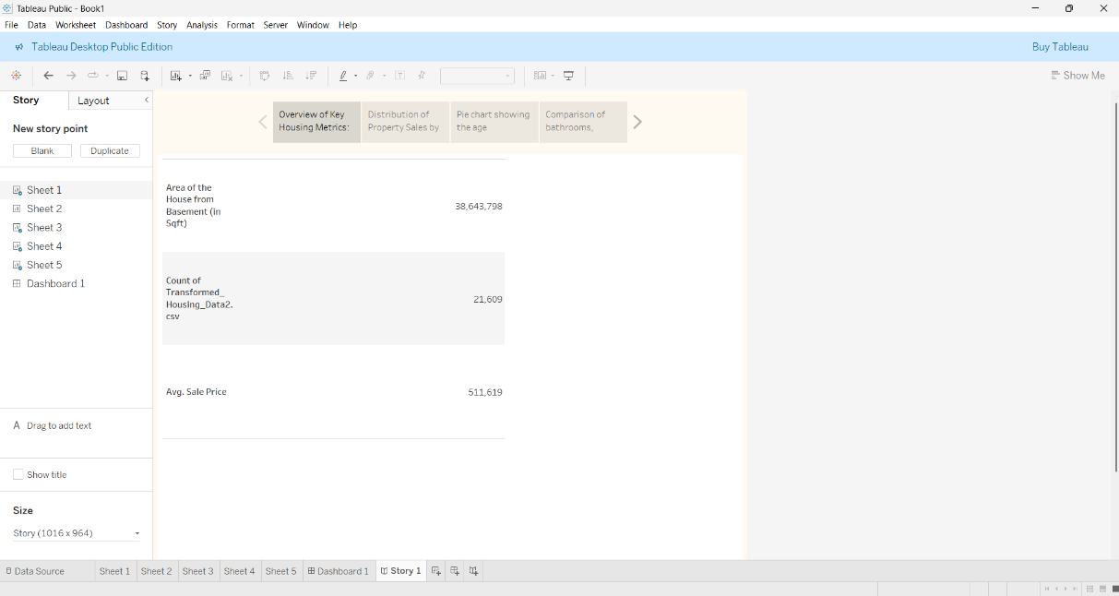 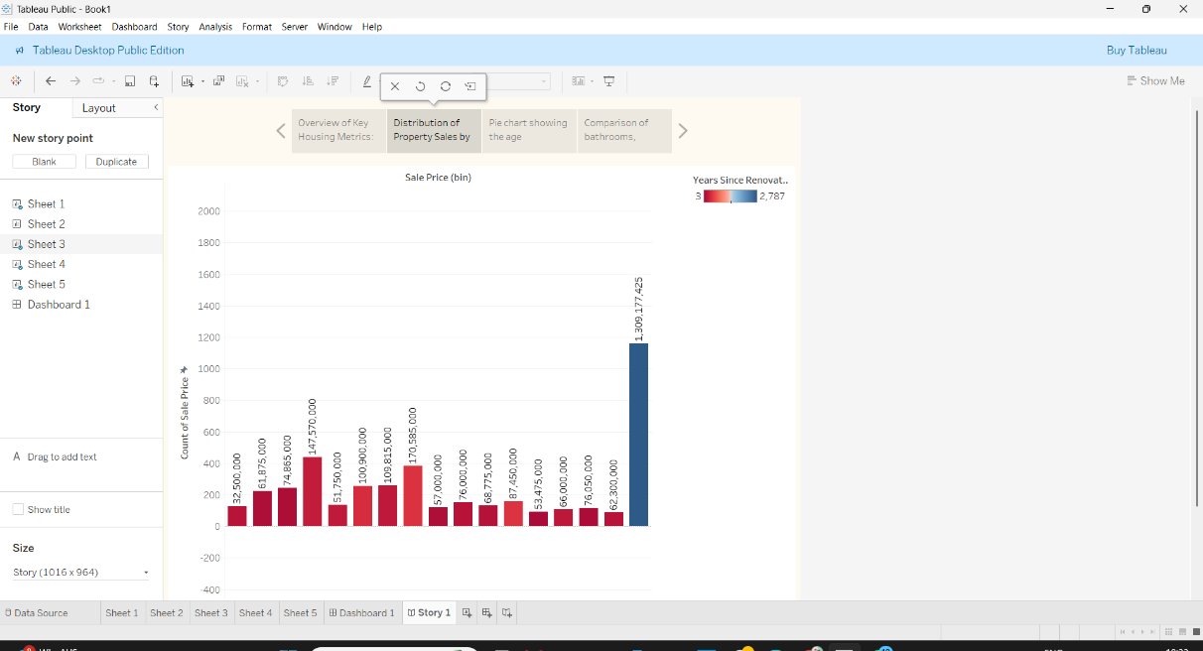

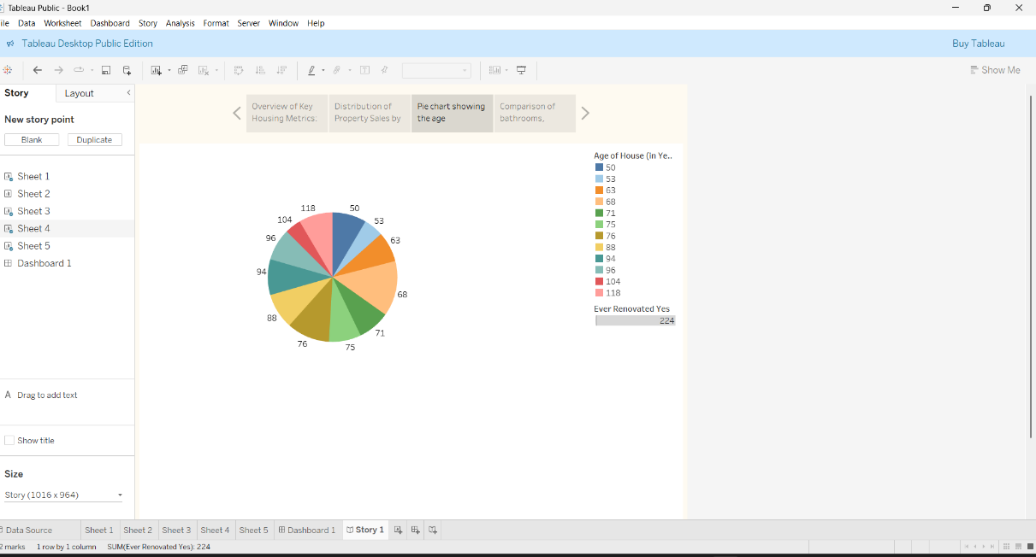 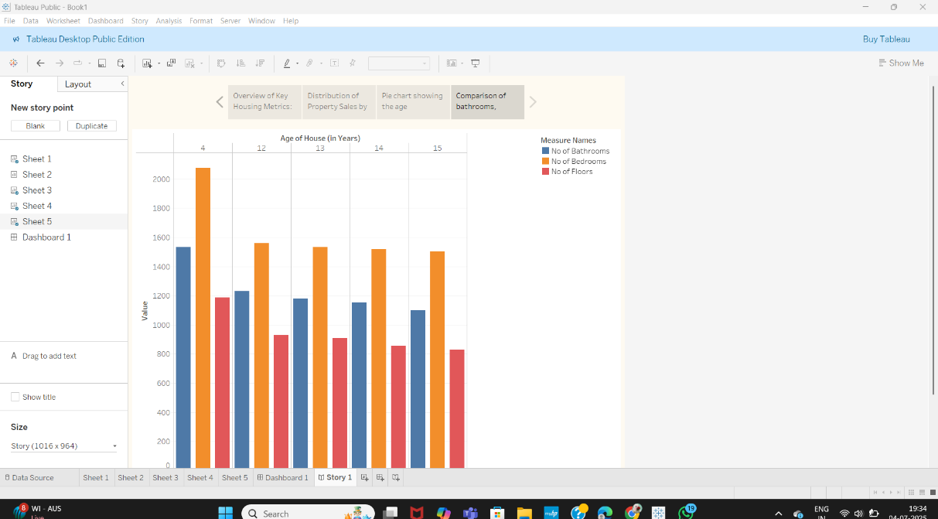

**Utilization of Filters**

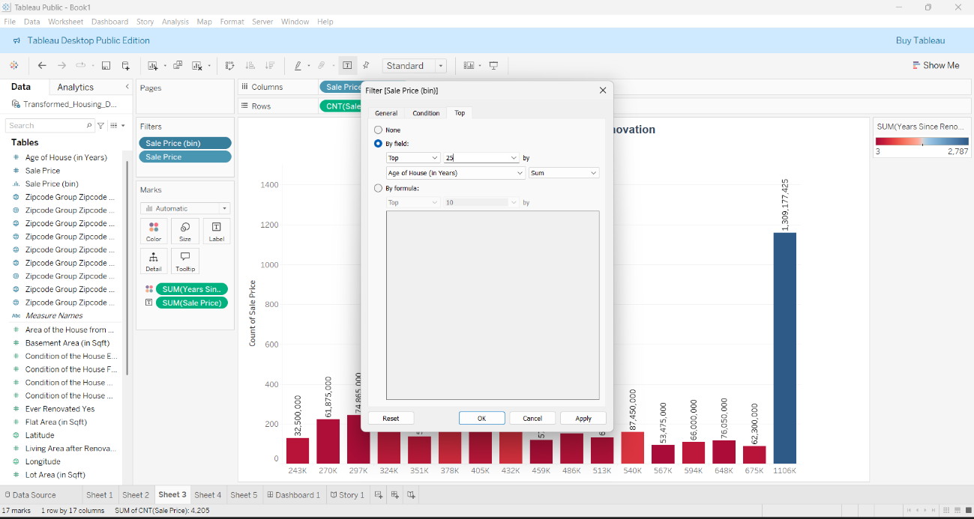 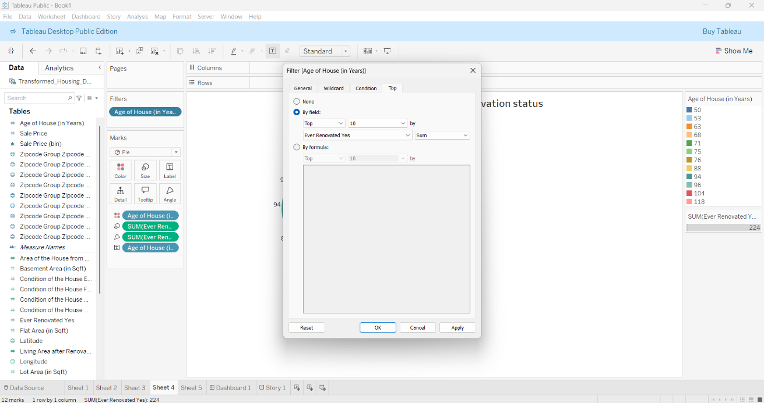

**Performance Testing**

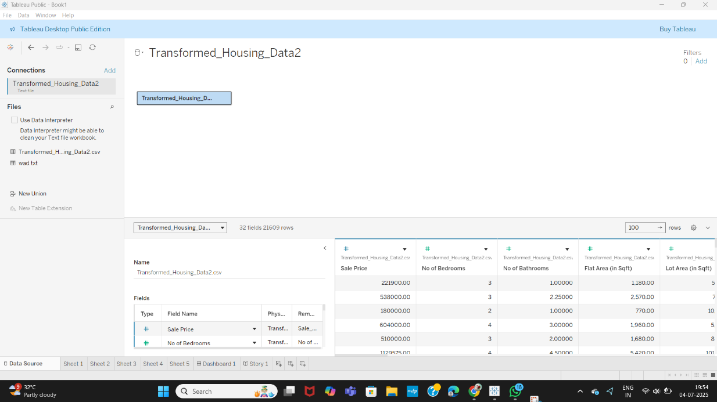

**Note: All visualizations were created using Tableau Public and the Transformed_Housing_Data2 dataset**